Wilbert Website Licensee Quick Start
Please complete the following worksheet and return to Peacock Marketing Group (info@peacockmarketing.net).
*Photos/Logos: To attach a photo to this document, place your cursor in the correct cell of the worksheet and select Insert and then Picture from the Word toolbar. All images should be low resolution and jpg or png.

So We Can Get Started
Refer to www.wilbertcore.com to see which sections can be customized. Visit wilbertcore.com/websiteinfo for samples.

Peacock Marketing Group Contacts
Sylvelie Franke (864) 431-3332; Terri Hoffman (864) 901-7563; Lisa Anderson (864) 569-5949

Company name:
Physical Address:
Main Phone #:
Company logo (if different from Wilbert logo):
Counties in your territory:
Products to omit from website (for example, The Citadel):
Name(s) and email address(es) of employees that should have Administration rights:
(to make website updates)
Billing Name, Address, and Email (50% upfront/50% at completion)
HOME PAGE
Banner Image  select one  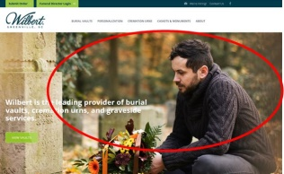 | ☐ Please select a stock image for me.  ☐ Custom image (please name it ”home-banner” and attach to your message. Specs:1400 x 600 pixels)  *You will be able to change this image through the CMS as often as you like.
Banner Headline  select one  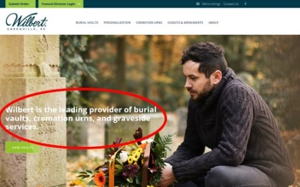 | ☐ Wilbert is the leading provider of burial vaults, cremation urns and gravesite services.  ☐ Commemorating Life with Respect.  ☐ The first name in memorialization.  ☐ Wilbert has been serving the funeral industry since 1928.  ☐ Other: Please specify:
Banner Green Button Text  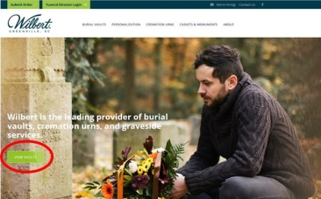 | ☐ Use default: VIEW VAULTS  ☐ Replace with your text choice and page link:
Green Text Box under Banner  select one  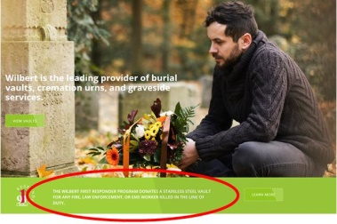 | ☐ Use Default: First Responder logo, text and button  ☐ Replace with the following Text and link:  For logo replacement, please send file in .png
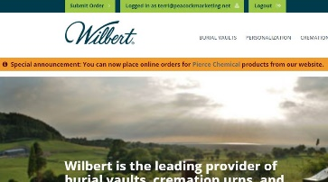 | ☐ I am interested in the Special Announcement Banner add-on ($100)
Videos  select 4  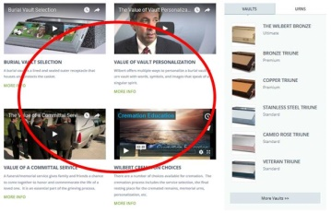 | ☐ Burial Vault Selection ☐ Value of a Committal Service  ☐ Burial Vault Key Differences ☐ Cremation Choices (2 mins)  ☐ Clear Vault ☐ Cremation Choices (4 mins)  ☐ Other (please insert link or embed code from YouTube or Vimeo):
Personalization Section  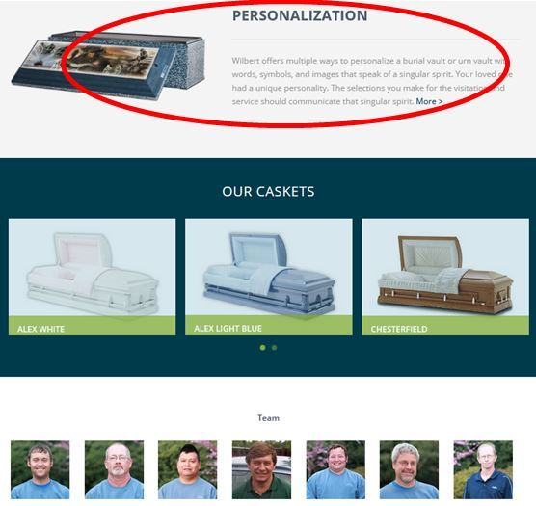 | ☐ Use Default: Personalization (text and image)  ☐ Other: Please provide title, text and choice of product for image (240 – 260 characters, ~44 words).
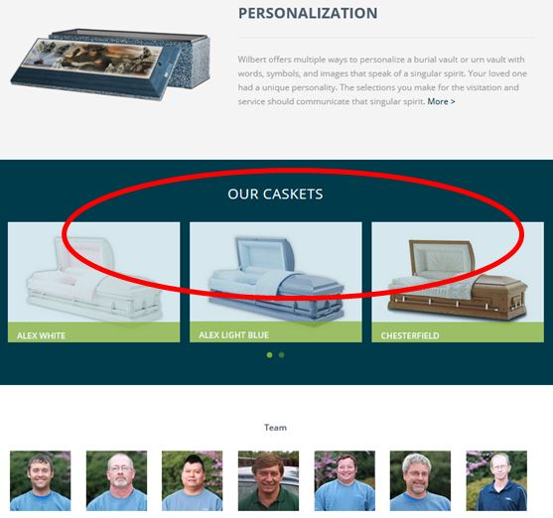  Photo Slider | ☐ Name of Album to Insert: _______________________________________________________  (caskets for example, but the photos could be anything like photos of events, office, etc).  *Licensee must load images into an album through the CMS with captions. Minimum of 3 images. Ideally the same pixel width and height.  Specs: 370 x 260 pixels
Team Section  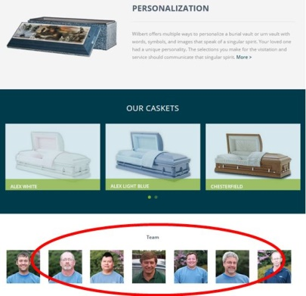 | ☐ Yes, I want to show team members (upload photos to team album in CMS)  ☐ I prefer to hide this section  ☐ Substitute photos of ________________ instead.  Specs: 130 x 130 pixels
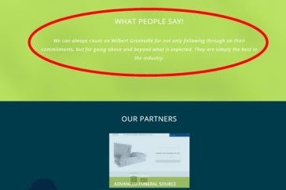  Customer Quote Section | ☐ Yes, I want to use a quote (funeral home, Wilbert, or other):  ☐ Omit this section.  ☐ Please insert this text instead:
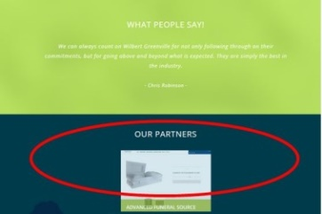  Partners Section | ☐ Yes, I want to list logos of partners (please attach logos or screenshots in .jpg or .png format)  ☐ Omit this section.  ☐ I prefer to use this section for:
PREFERRED NEW MENU
Please determine the titles and sequence of the main menu. Use the suggested titles or create your own. Number the menus, starting with #1, of how you want them to appear left to right. | 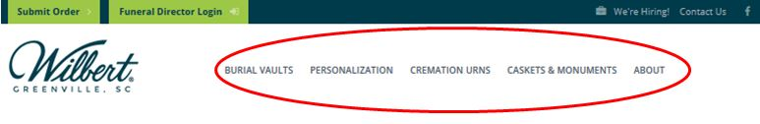  Burial Vaults Personalization Cremation Urns Pet Cremation  Crematory Concrete Products Caskets About  __________ __________ __________ __________
- For addl pages (monuments, caskets etc) insert content (text + images):
About Page  select all that apply  *Other content will be migrated from current website. | ☐ Include Ultimate Service Provider  ☐ Replace Ultimate Service Provider with the below text and attach .png image to email  ☐ Include Photo Slider; specify name of album from CMS _______________________________
History of Company:
Company Photos (historical or current):
Vault Services Offered | ☐Tents ☐Grass ☐chairs ☒Grave Digging ☐Other
Personalization Page  Select all that apply | ☐ I would like to add photos of my custom vault images (upload .jpg photos to 2 albums in CMS; 1 with horizontal images; 1 with vertical images).  ☐ Include standard Wilbert Legacy images
Activate Job Postings? | ☐ Yes, activate Job Postings; please attach text in word document or email.  ☐ No, activate Job Postings later.  ☐ I am also interested in adding an online job application ($750).

Technical Items
Do you have a website? | ☐Yes ☐No  If Yes, please provide hosting contact information for transfer of ownership:
Do you own a website domain(s)? | ☐Yes ☐No  If Yes, please include domain name and person who has control/access:
Website Main Contact(s)
(future correspondence from Peacock Marketing):

